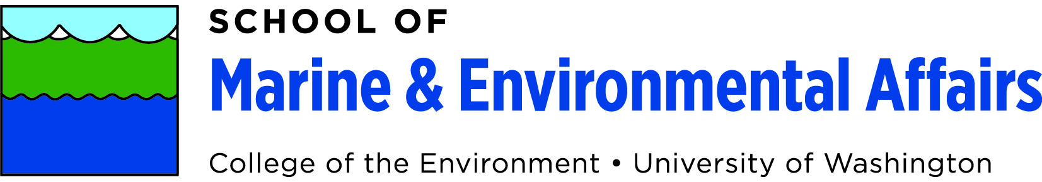

**AGENDA**

**SMEA Faculty Meeting Thursday, March 2, 2023**

**12:00 pm – 12:50 pm**

**12:50-1:30 pm executive session**

**In-person attendance @** [**Fish Sciences (FSH) Room 207**](https://www.washington.edu/maps/#!/fsh)

**or**

**Virtual attendance via Zoom**

[**https://washington.zoom.us/j/9175532830**](https://washington.zoom.us/j/9175532830) **Meeting ID: 917 553 2830**

**Phone In:** +1 206 337 9723 US (Seattle)

12:00 – 12:50pm: Welcome, Announcements, Old & New Business

1. DOLSAK: Announcements & adopt February minutes (5 min)
2. GRIFF: Spring capstone & thesis presentation discussion (10 min)
3. GRIFF: Ad Hoc Committee mission statement (15 min)
4. JEDI Committee Updates (10 min)- Leslie Nguyen
5. STUDENTS: Student business (10 min)

12:50 – 1:30pm: Executive session